1. Naloga

RGB, (1800 X 2400 X 3B)/7000B/s ~ 1851s

1. Naloga

Ack(2)

1. Naloga

Ack(1)

M(2)

Ack(2)

1. Naloga

p = 3, q = 17

n = 3\*17 = 51

m = (3-1)\*(17-1) = 32

e = 3 ali 5 ali 7 ali 9 ali …

d = 11

JK: (51, 3)

ZK: (51, 11)

»10« = 10^3 mod 51 = »31«

1. Naloga

p = 5, q = 11

n = 55

m = 40

e = 3

d = 27

JK: (55, 3)

ZK: (55, 27)

»15« = 15^3 mod 55 = »20«

Kolokvij

C = 6

JK: (187,107)

P = 11, q = 17

(107\*d) mod 160 = 1

D = 3

6^3 mod 187 = 29

Omrežja

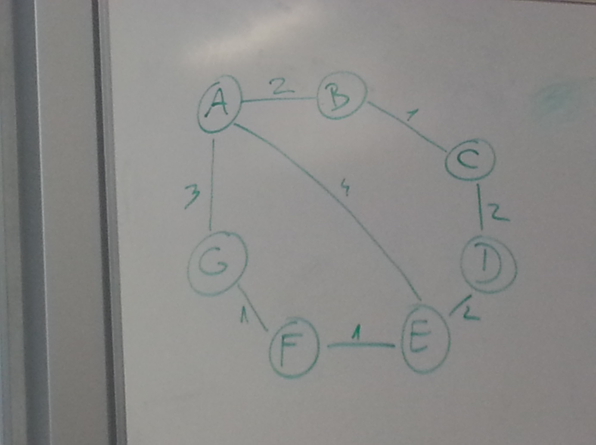

1. c-d-e-f-g (6); c-b-a-g (6); c-d-e-a-g (11); c-b-a-e-f-g (9)
2. c-d-e-f-g in e-b-a-g – zakasnitev je 6
3. Obroč ; bus
4. Ne. Ker imamo 2 poti
5. Ack(2) ; še nekrat pošjle M(2)

Sherlock

N = 143, d = 103, C = 128

P= 11, q = 13

m = 120

(e\*d) mod 120 = 1

e = 7

JK: (143, 7)

C = 2^7 = M^7 mod 143

M = 2

M^7 mod 143 = 128

M^7 = x \* 143 + 128

M^7 = 0 \* 143 + 2^7 -> M^7 = 2^7